EXTORTION 17
LEGACY RIDE
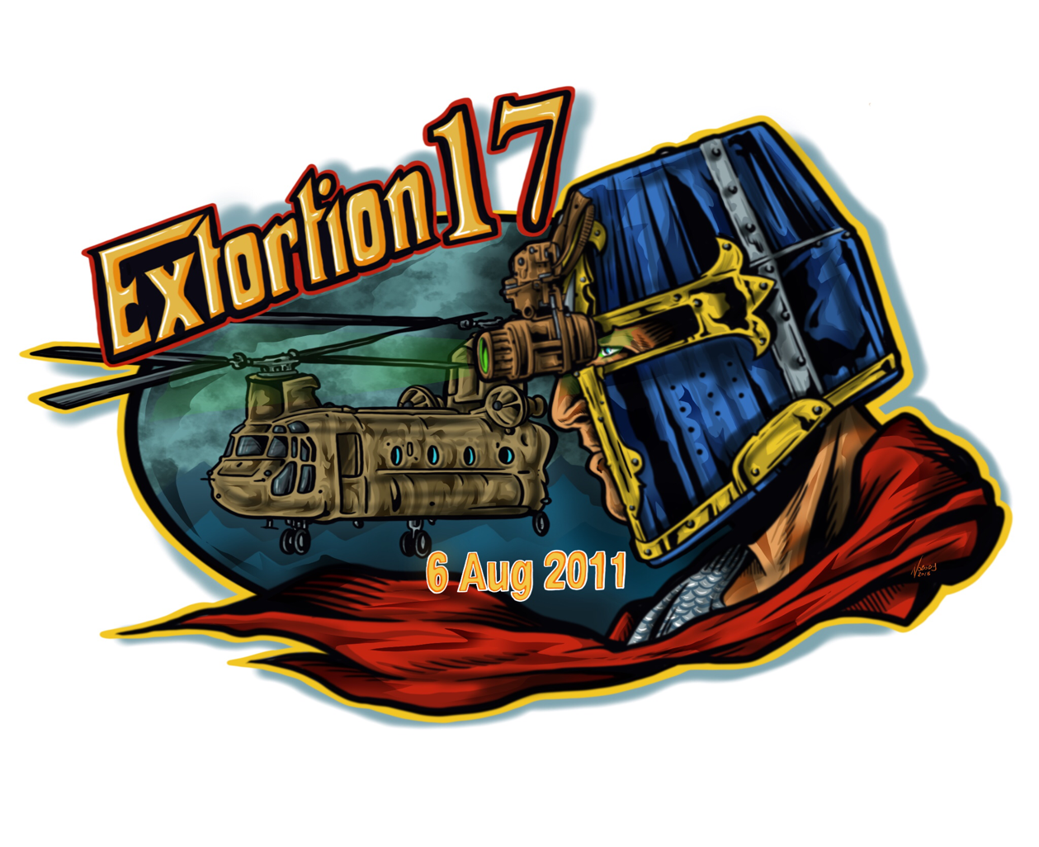
August 4, 2018

IN HONOR OF OUR FALLEN HEROES OF
AUGUST 6, 2011

SPONSORSHIP OPPORTUNITIES

SATURDAY, AUGUST 4, 2018

REGISTRATION: 8 AM - 9:30 AM Lendy’s Cafe
POST-RIDE PARTY: 11 AM – 4 PM Chick’s Oyster Bar

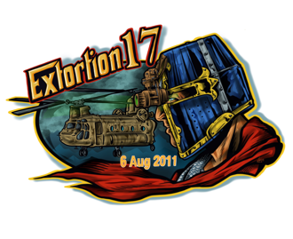
Dear Extortion 17 Supporter,

The Annual Extortion 17 Legacy Ride will be held on Saturday, August 4, 2018. Our ride is dedicated to the memory of the 30 active duty military, and 1 military working dog who were killed in action on August 6, 2011, when a CH–47 helicopter was shot down by enemy fire in Wardak Province, Afghanistan. This ride provides an opportunity for the community and the Gold Star Families of August 6, 2011, to come together to honor these incredible men and their ultimate sacrifice.

The Jason Ray Workman Legacy Foundation is honored to announce our 2nd year officially hosting the Annual Extortion 17 Legacy Ride. We have taken over for Torrie Rodgers, as she has retired. My name is Stacey Workman, and I am Jason Workman’s widow. I, along with his brothers and close friends, have started this Foundation to manage all Extortion 17 events this year and in the future. We do apologize for any rough patches that occurred over the last few years, but this Foundation is here to ensure that Our Men (and Bart) of Extortion 17 are properly honored. This year, proceeds raised from this event will not only go to Honor, Protect, and Preserve the Legacies of The 31 Heroes on the Extortion 17 Mission, but to fund and give support to Extortion 17 families and all the charities that have helped us, collectively, and honored our men since 2011. We are forever grateful and hope to aid many other families in their darkest hours and time of need.

The day of the event registration will take place on August 4, 2018, from 8 AM – 9:30 AM, at Lendy’s Cafe, located at 1851 General Booth Blvd, Virginia Beach, VA, 23454. All pre & same day registrations will be $31 for riders & passengers on motorcycles or in vehicles. Times & locations for the event will be listed on Eventbrite – Annual Extortion 17 Legacy Ride 2018, the Jason Ray Workman Legacy Foundation Facebook page, and our website www.JRW250.org, which is currently being updated. Ticket purchase and any necessary forms can be filled out online at Eventbrite - EXTORTION 17 LEGACY RIDE 2018. Registration includes the ride, T-shirt and two beverage tickets. If riders cannot make it to Virginia Beach, they can register as a Virtual Rider for $31. Virtual riders will also receive a T-shirt to wear in their hometown to honor our heroes.

Beginning at 10 AM the day of the event, a police escorted motorcade will monitor the ride, ending at Chick’s Oyster Bar off of Shore Drive, located at 2143 Vista Circle, Virginia Beach, VA, 23451. Shortly after arrival, we have planned a ceremony to honor and remember Our Fallen Heroes at Chick’s from 11AM to 4PM. We also will be selling raffle tickets, with each purchase of a $5 ticket, raffles will be held with donated items from our community sponsors. This event is not only a wonderful opportunity to come together to remember the sacrifices of Our Heroes, but to also remember the sacrifices their families have made for our great nation.

We would be both honored and appreciative if your organization joined us on August 4 by choosing a sponsorship level, donating an item to the raffle, or by donating any items to be auctioned at a future date, beginning in 2019. The Jason Ray Workman Legacy Foundation is a 501(c) (3) non-profit organization. All donations are tax-deductible. As a thank you for your support, the Jason Ray Workman Legacy Foundation plans to display a banner at the entrances of all supporting establishments on the day of the event, showcasing the logos for all organizations that have chosen to sponsor or donate to this year’s raffle and/or future auctions. Sponsors will also be recognized on both our Facebook page and website as well during the Annual EX 17 events in August.

Thank you for your consideration and the continuous support of our fallen heroes and their families.

Sincerely,

The Jason Ray Workman Legacy Foundation

Established March 2017 EIN#82-0648232

Any questions regarding interest in support of this memorable event, please contact Extortion 17 Legacy Rides Event Coordinators:

Stacey Workman, CEO
StaceyWorkman.jrw250@gmail.com
Camy Thurbon, Special Event Coordinator CamalaThurbon.jrw250@gmail.com

SPONSORSHIP OPPORTUNITIES

Extortion 17 Presenting Sponsors
$10,000 and up
- 12 T-shirts Two
- 6 top tables with Premium table placement and reserved seating
- Most prominent logo on our 48 x 60 Banner & Promotion through website and Facebook

Platinum
$5,000
- 8 T-Shirts
- One 6 top table with Premium table placement and reserved seating
- Logo on our 48 x 60 Banner (2nd level of prominence)
Promotion through website and Facebook

Gold
$2,000
- 6 T-shirts
- Logo on our 48 x 60 Banner
- Promotion through website and Facebook

Silver
$1,000
- 4 T-shirts
- Logo on our 48 x 60 Banner
- Promotion through website and Facebook

Bronze
$500
- 2 T-Shirts
- Logo on our 48 x 60 Banner
- Promotion through website and Facebook

EXTORTION 17 LEGACY RIDE
Fundraiser: Legacy Ride Honoring our Fallen Brothers Saturday August 4, 2018
Registration: Lendy’s Cafe 1581 General Booth Blvd #101 23454
Post Ride Party: Chick’s Oyster Bar 2143 Vista Circle 23451

Auction & Sponsor Commitment Form
Please circle your sponsorship level (See Sponsor benefits for detailed information)
- $10,000 - Extortion 17 Presenting Sponsor
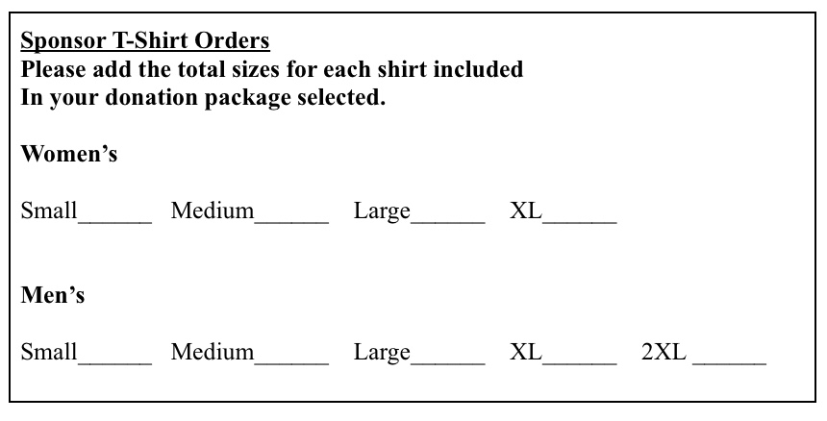
- $5,000 - Platinum Sponsorship
- $2,000 - Gold Sponsorship
- $1,000 - Silver Sponsorship
- $500 - Bronze Sponsorship
- Auction Donation – (value & description) ________________________________ ______________________________________________________________________________________________________________________________
Company Name: __________________________________________________
Contact Person: ___________________________________________________ Email: __________________________________________________________
Phone: ___________________Fax: ___________________________________
Address: ________________________________________________________ City, State, & Zip: ________________________________________________

**Please make checks payable to The Jason Ray Workman Legacy Foundation

Mailing Address:
Attn: Jason Ray Workman Legacy Foundation
Regus, 780 Lynnhaven Pkwy, Suite #400 Virginia Beach, VA 23452

The Jason Ray Workman Legacy Foundation is a 501(c)(3) organization, Federal Tax ID #82-820648232

